**Instructions about the project:**

Dependencies: Intellij IDEA, maven 3.6.3, TestNG, chromedriver, all dependencies from POM.xml file are necessary and they should work properly;

TestNG Runner configuration:

Test kind: Suite

In single module

Suite: Project/target/test-classes/config/runner.xml

VM options: -DmyTag="--tags @test"

JRE: Default (openjdk-17 – SDK of ‘Project’ module)

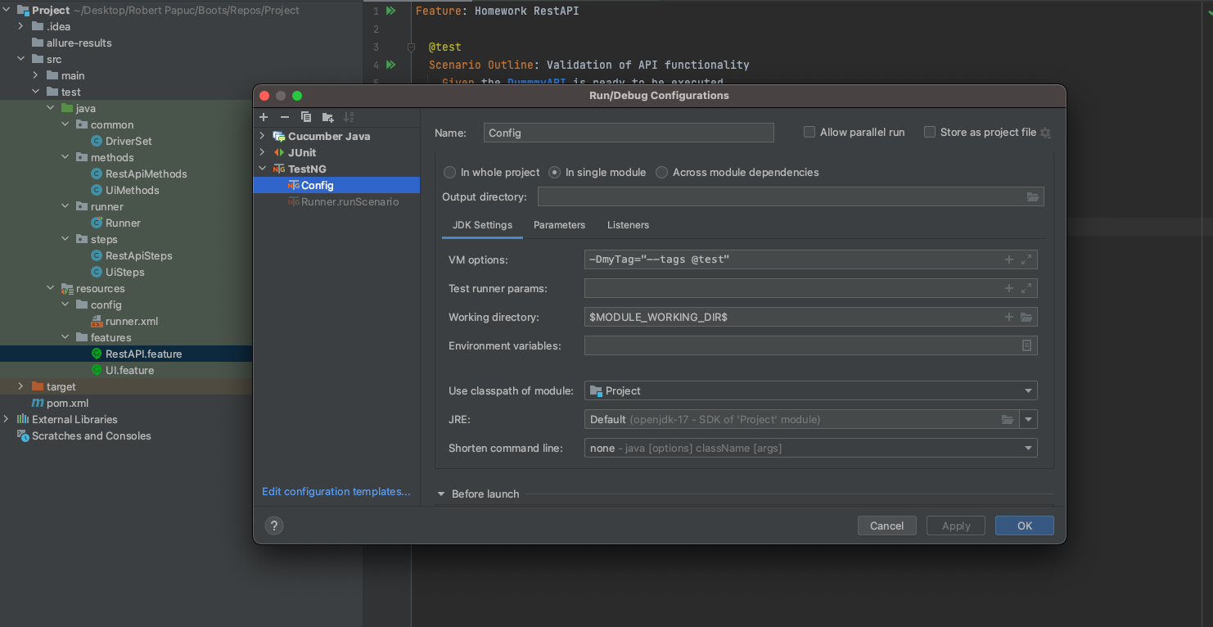

Tests were run on Chrome browser version 108.

**In order to be able to run the tests, you need to set the path for your chromedriver in DriverSet.java class file at line code 11**

**Notes about the REST API test:**

* If I send the request right after I just sent another request, I’m receiving 429 response (too many requests at a given time). This is why at each method you will see a Thread.sleep(60000);
* Sometimes I receive also “java.lang.ClassCastException” error but if the request is sent in 1 min (not earlier than the previous request), it should not return this error;
* Dummy API examples are not working properly. I tested also manually in Postman tool and the new employee (step #2 from Homework) is not added in the list even if the response is 200. This means that I couldn’t show “that employees with age number higher than 30 has modified” (step 4 from Homework). This is why the REST API scenario will fail at this step (Line code 46 from RestApiSteps.java class file).

**Notes about the UI test:**

* The scenario will pass with the expectation that the user cannot remove again one of the products from the Cart page (step 4 from Homework) (Line code 33 from UiSteps.java class file)